

**ALLAZOHEALTH CODING CHALLENGE**

Thank you for your interest in AllazoHealth. I would like to invite you to take the coding challenge described below. The challenge helps us understand how you approach problems. Please report to us how much time you spent on each part, when you return it.

Please provide your solutions using SQL language. The sample tables provided in the questions are just that! Your solutions should be as general as possible.

# Problem : Calculating days a patient did not have any pills

Using a patient’s pharmacy claims we want to calculate how many days she or he was not covered by medication.

Assume the following:

* The period starts at the day of the first fill and ends on the day of the last fill.
* A patient takes 1 pill per day, starting at the day he/she bought the pills
* If a patient buys more pills before his/her supply runs out, the newly bought pills get added to the already existing supply (pills don’t expire nor go to waste)

|  |  |
| --- | --- |
| **Fill day** | **Amount of pills** |
| 0 | 30 |
| 40 | 30 |
| 60 | 30 |
| 85 | 30 |

Table 1: Example data

For the example shown in table 1, the answer would be 10 (the patient does not have any pills between days 30-39).

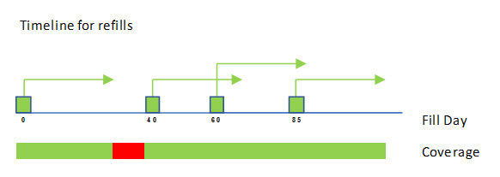

Figure 1: Example timeline

Using the sample table from above, code in SQL how you would calculate the number of days a patient did not have any pills. We recommend you to test your code with other examples and edge cases.